
PERIOIDC TEST 3 - (2021-22)
Answer Key
Subject: PHYSICS  Grade: XII |  | Max. Marks: 35  Time: 1 Hr 10 Minutes
SECTION A
1. | a)The frequency of the microwaves must match the resonant frequency of the water molecules. |  | 1
2. | b)moving in a circular orbit |  | 1
3. | c)30° |  | 1
4. | b)f1 > f and f2 becomes negative |  | 1
5 | d)1.8 × 10⁸ m/s |  | 1
 | SECTION B
6 | Formula  Ans:1.8m |  | ½  1/2
7. | The 7 m high partition wall in the room of ceiling height 10 m has a 3 m wide opening (slit). Hence sound waves having their wavelengths comparable with the width of the slit diffract easily but the light waves are of much smaller wavelength 10⁻⁷ m so diffraction can’t take place and waves can’t reach students on other side of the partition |  | 1
8 | Diagram |  | 1
9 | 25 cm
10 | Formula  Solution w1: w2 = 16 : 1 |  | ½  ½
 | SECTION C
11 | a)  b) 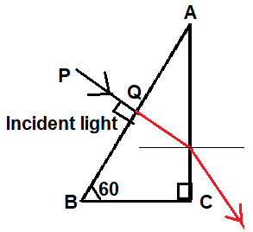 Reason: Critical angle > 30⁰ |  | 1  +  1
12 | For the convex lens, f₁ = +30 cm and object distance u₁ = - 40 cm.  1 / f₁ = 1/v₁ - 1/u₁  => 1 / +30 = 1/v₁ - 1/-40  => 1/v₁ = 1/30 - 1/40  => 1/120  => v₁ = +120 cm, a real image is formed  On introducing a concave lens, f₂ = -50 cm  and u₂ = 120 - 20 = +100 cm from the concave lens  1/f₂ = 1/v₂ - 1/u₂  = 1/-50 = 1/v₂ - 1/+100  = v₂ = - 100 cm  A virtual image is formed at all the distances of 100 cm from the concave lens.  The change in position between the real image and the virtual image is 100 cm + 100 cm = +200 cm to the left of its original position. |  | ½  ½  ½  ½
13 | Diagram  Proof of Snell’s Law |  | ½  1 1/2
14 | Set A: stable interference pattern, the positions of maxima and minima does not change with time.  Set B : positions of maxima and minima will change rapidly with time and an average uniform intensity distribution will be observed on the screen. |  | 1  1
 | SECTION D
15 | Diagarm  λ1- X rays  λ2- Infra red  λ3- UV  λ2, λ3, λ1 |  | 1  ½  ½  ½  ½
16 | - Diagram  - Let D be diameter of moon, d diameter of image of moon formed by objective and r the distance of moon from objective lens,  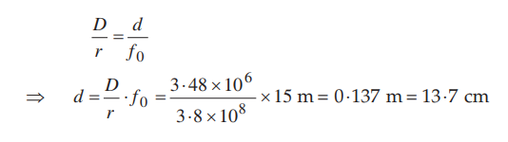 |  | 1  2
17 | - Diagrm  Derivation  - Power increases |  | ½  1 ½  1
18 | a) Diagram  b) Formula used  Solution width a = 0.2 mm |  | 1  2
 | SECTION E
19 | - When two monochromatic waves, represented by  y₁ = a cosωt and y₂ = a cos(ωt + ø) superpose on each other, the resultant wave is  y = y1 + y2  = a cosωt + a cos(ωt + ø)  = 2a cos ø /2 cos(ωt + ø/2)  The resultant amplitude A = 2a cos ø /2  Since intensity is directly proportional to the square of the amplitude  I = 4a² cos² ø /2  = 4 I₀ cos² ø /2  - m/n = λ1/λ2 = 5/4  Y = 5Dλ/d =7.8 x 10⁻⁴m |  | 1  1  1  1  1

